**Underwater Backscatter Networking Tutorial**

**Mechanical Fabrication of Nodes:**

What you will need:

1. Steminc ceramic cylinder
2. Pressure pot
3. PLA printing material
4. polyurethane WC-575A mixture from BJB enterprises
5. Rubber sheet
6. Screws and nuts
7. Access to 3D printer, soldering station, laser cutter

The main component of our transducer is a piezoelectric cylinder. We purchased a ceramic cylinder (fig. 1) from Steminc with an in-air resonance frequency of 17 kHz, a radius of 2.5 cm, and a length of 4 cm.

Purchase link :<https://www.steminc.com/PZT/en/piezo-ceramic-cylinder-541x47x40mm-17-khz>



Fig. 1 Ceramic cylinder

**Procedure:**

1- First, we soldered two wires to the two electrodes of the piezoelectric ceramic (i.e., the inner and outer surfaces of the cylinder) as represented below.

Fig. 2 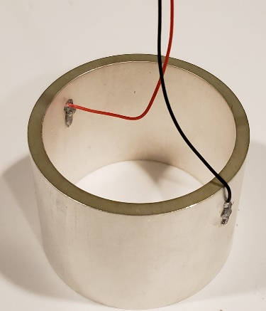

2- We 3D printed the base and the top cap from as well as a cylindrical mold to house the ceramic cylinder and encapsulation polymer.

Link for 3D molds: How do you want to upload the molds??????????

3-Then, we laser cut rubber washers and placed them on the top and bottom of the cylinder, then placed it on a base and added a top cap.



Fig3. Rubber washers

4- The setup is held tight using a screw and locking nut, then placed inside the mold.

Link for screws and nuts:

<https://www.homedepot.com/p/Everbilt-M3-5-Stainless-Steel-Metric-Hex-Nut-2-Piece-per-Bag-842318/204836105>

[https://www.homedepot.com/p/Everbilt-M3-0-5-x-20-mm-Phillips-Pan-Head-Stainless- Steel-Machine-Screw-2-Pack-842738/204283765](https://www.homedepot.com/p/Everbilt-M3-0-5-x-20-mm-Phillips-Pan-Head-Stainless-%20%20Steel-Machine-Screw-2-Pack-842738/204283765)

5- Finally, we prepared the encapsulation polymer, we used the polyurethane WC-575A/B mixture from BJB enterprises. The mix ratio by volume is A-100 B-94. We placed the mixture in a pressure pot at 60 (4atm) psi for at least 9 hours.

Pressure pot link: <https://www.smooth-on.com/products/pressure-chamber/>

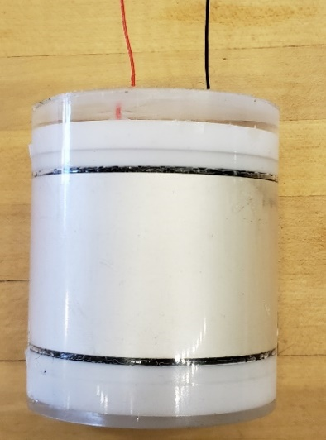

Fig 4. Encapsulated transducer

**Hardware Tutorial**

1. **Energy Harvesting Unit**

Let’s start by building the harvesting unit which is composed of two main parts the voltage multiplier and a supercapacitorto store the energy. The output of the voltage multiplier is a DC rectified and multiplied version of the incoming signal. In our design we used a four-stage voltage multiplier with this architecture.

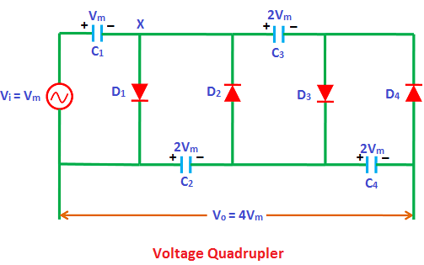

Fig1: Single ended voltage multiplier

Link for more information on voltage multipliers:

<https://www.physics-and-radio-electronics.com/electronic-devices-and-circuits/rectifier/voltagemultipliers-voltagedoubler-tripler-quadrupler.html>

**Note1:** The DC voltage at the output of the voltage regulator is given by:

**Vo = N*(Vmax-Vth)**

Where N is the number of stages of the voltage multiplier (4 in our case), Vmax is the amplitude of the incoming signal, and Vth is the threshold voltage of the diodes being used.

**Note2:** The DC output of the voltage multiplier can be negative or positive depending on the orientation of the diodes.

**Note3:** The voltage multiplier acts as an envelope detector (low-pass filter); thus, when transmitting a PWM signal the output of the voltage regulator will look like the envelope of a sinusoidal signal that turns on and off. Like in the image below. If lower capacitances in the voltage multiplier are used the discharging time can be decreased; however, this will also cause a small ripple to appear.

**Note4:** The schematic in Fig.1 shows a single ended voltage multiplier for simplicity. However, since the output of the piezo electric is differential in our circuit design, we have a differential voltage multiplier which also includes a mirror image of the schematic in Fig1. (You will find the full architecture in our PCB layout)

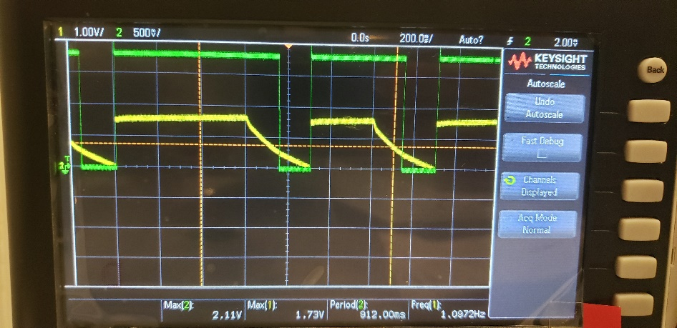

Fig2: Yellow curve is the PWM signal after the voltage regulator. Green curve is the Schmitt triggered version of the yellow signal.

Connect the output of the rectifier to the supercapacitor (10000 pF) via two diodes in series like the image below. 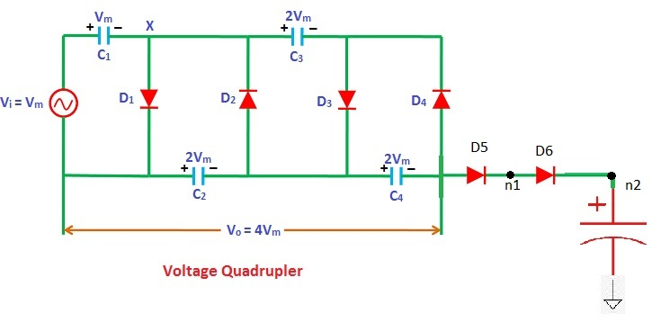

1. **Downlink Decoder**

The decoder in our circuit is composed by a level shifter (TXB0302) fig4, which incorporates a Schmitt Trigger, and a pull-down resistor that is turned on by the MCU(MSP430G2553) when decoding is desired. This part of the circuit converts the output of the PWM signal into a nice clean square wave that can be decoded by the MCU. The reason for the pull-down resistor is to fasten the discharging time of the voltage regulator’s capacitors and improve SNR. The level shifter shifts the signal to a point where that can be detected for the MCU. The output of the level shifter is the green curve in fig2.

**Note1:** The used MCU incorporates a Schmitt trigger at its input; thus, we could have used only a level shifter.

**Note2:** The level shifter output is shifted up to the voltage fed into VccB

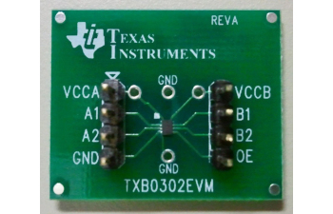

Fig4: Level shifter TXB0302

**Connections:**

The level shifter is connected to the rest of the circuit as follows. The junction between diodes D5 and D6 is connected to both VccA and A1. VccB is connected to the output of the voltage regulator. B1 is the output of the level shifter so it is connected the pin 1.1 of our MCU. The OE pin is connected to any pin of our MCU that outputs a constant voltage when it is on and ready to decode. Finally, GND is connected to ground.

**Note:** The output enable should also be connected to GND via a 47Kohm resistor as suggested by Texas Instruments.

1. **Voltage Regulator:**

A voltage regulator is needed in our circuit in order to drive the MCU and level shifter with a constant and stable voltage. The voltage regulator used was a lp5900sd(1.8V) because we want to exploit our MCU capability to operate when driven at its minimum voltage of 1.6V.

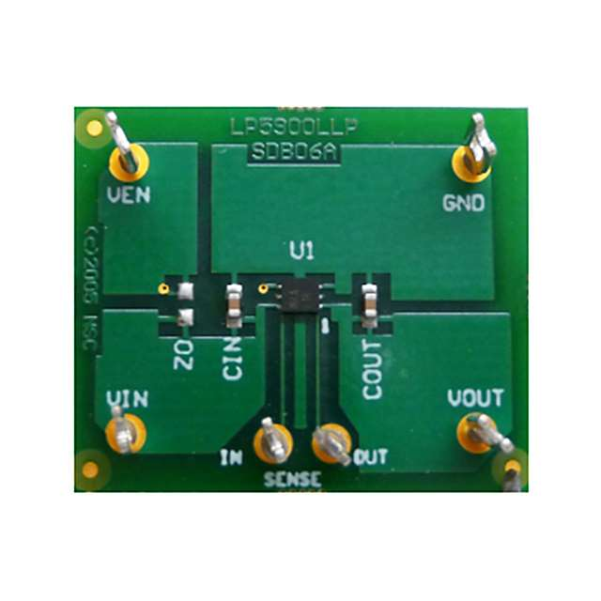

Fig5: lp5900SD

**Connections:**

The voltage regulator is connected to the rest of the circuit as follows. Ven and Vin are both connected to the positive end of the supercapacitor. Vout is connected to the VccB pin of the level shifter and to the 3.3V pin of our MCU. Finally, GND is connected to ground.

**Note1**: Vout and Vin both need a 0.47nF bypass capacitor as described in the image below.

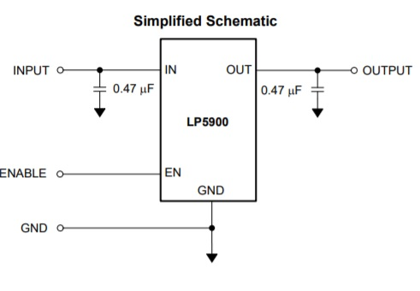

Fig6: LP5900 connections

**Note2:** If the Ven is higher than 1.2 V the LP5900 will activate and it will saturate at approximately 1.8V when the Vin reaches values higher than 1.8V.

1. **Backscatter switches:**

**Note1:** The backscatter switches consist of two N-channel MOSFETs connected in series sharing a common ground. Their sources are connected to each other and to ground. Their gates are connected to the same pin of the MCU (pin 1.0) which turns them on and off. Switching between reflective and absorptive state. The drain of each MOSFET is connected to one terminal of the piezo.

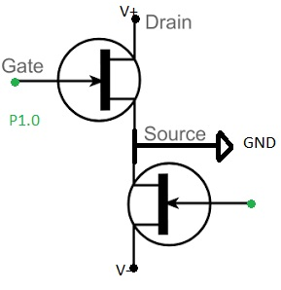

1. **Impedance Matching Network:**

The piezo electric source has a characteristic impedance. Thus, in order to ensure maximum power transfer to our circuit we added an impedance matching network. We used an L shape network composed by only inductors and capacitors. We used the E4990A Impedance analyzer to measure the impedance of the source and load.

**The PCB design is shown below:**

PCB layout link:

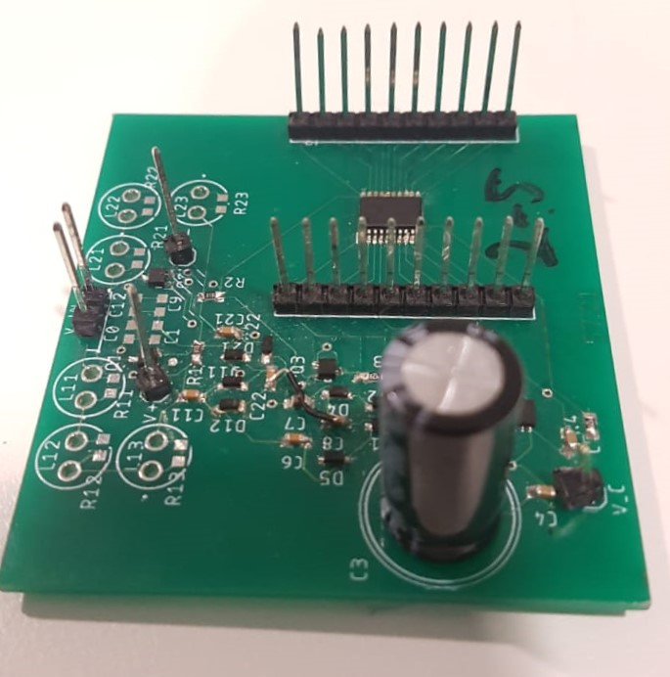

Note that the PCB does not include the impedance matching circuit, but still the PCB can power up the MCU and control the switching of MOSFETs if the super-capacitor can charge up to at least 2.5V from the differential PWM input signal.

The details for inputs and outputs are given below:

This pin is the common ground for the entire PCB. Use this pin as a reference when measuring voltages across different components using oscilloscope.

This pin will receive the envelop of the PWM signal in the form of a square wave which is the output of the level-shifter. If this pin shows a different waveform then check the level shifter and see if it is working properly.

This pin will output the signal which will control the switching of mosfets. The output of this pin depends entirely on the decoding algorithm in the MCU and also on the input from pin “B”

These set of pins can also be used to input the differential PWM signal. You can use these pins even if you don’t have the impedance matching circuit

These set of pins will be used to input the differential PWM signal from the piezoelectric device. Use these pins only after you have populated the PCB will all the components which are required for impedance matching

This pin is the VCC input to the MCU. If the voltage on this pin is lower than 1.8V then the MCU will not power up.

**Transmitter (Tx)**

What you would need:

1. Our in-house built transducer
2. Laptop or desktop computer with audio jack output
3. Xli2500 Two-channel 750W power amplifier

**Note:**

The transmitted signal is generated using MATLAB, we first transmit a pure sine at around 17kHz the resonant frequency of our transducer. Secondly, we employ pulse width modulation (PWM) where the ‘1’ bit is twice as long as the ‘0’ bit.

PAB (Tx) MATLAB code

%The transmission consists of two stages: energy harvesting stage and

%communication stage: During the energy harvesting stage we transmit a pure

%sinusoidal signal and during the communication stage we transmit a PWM

%that encodes 1's and 0's (being a 1 twice longer that a 0). Finally, we

%transmit again a pure sinusoidal that will be backscattered by the node.

% Generate purely sinusoidal

f = 15000; %15Khz

Fs = 44100; %Sampling frequency

ts = 1/Fs;

T = 10; % Generate 10 seconds

t = 0:ts:T;

signal = sin(2*pi*f.*t);

%%%%%%%%%%%%%%%%%%%%%%%%

%Generate bits

preamble = [1 0 1 1 0 1 1 1 0 1 0 0 1 0 0 0 1 0 1 0];

bit1 = repmat(1,1,2*9000);

bit0 = repmat(1,1,9000);

zero = repmat(0,1,9000);

sq = [];

for bit = preamble

if bit == 1

sq = [sq bit1 zero];

elseif bit == 0

sq = [sq bit0 zero];

end

end

%modulated signal

PWM = sq(1:end-length(zero)+1).*signal;

%%%%%%%%%%%%%%%%%%%%%%%%

%Charge the PAB node and then transmit preamble

sound(signal, Fs);

pause(12) %wait for 12 seconds

sound(PWM, Fs);

pause(12)

sound(signal,Fs)

**Receiver (Rx)**

What you would need:

1. H2A Hydrophone (Fig. 1)
2. Laptop or desktop computer with audio jack input
3. Audacity software
4. Our MATLAB decoder

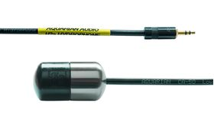

Fig. 1

Link:

<https://www.aquarianaudio.com/h2a-hydrophone.html>

<https://www.audacityteam.org/>

MATLAB decoder:

Our decoder identifies the different transmitted frequencies on the downlink using FFT and peak detection. It then down-converts the signals to baseband by multiplying each of them with its respective carrier frequency. The receiver then employs a Butterworth filter on each of the receive channels to isolate the signal of interest and reduce interference from concurrent transmissions. Subsequently, it performs standard packet detection and carrier frequency offset (CFO) correction using the preamble. Finally, it employs a maximum likelihood decoder to decode the FM0 decoded bits.

Code link: How to upload the code???????? Do you guys want to share the repository????

**Microcontroller (MSP430)**

In process…………………………………..